Design a Model Irrigation System
Instructions: As a group, read the following information aloud.
Did you know?
Nevada is one of the premier garlic growing areas in the world. It’s proven to be an ideal crop for Northern Nevada, because it will thrive despite temperature extremes, low amounts of precipitation, and dry, rocky soil. Most of the garlic grown in Nevada is sold as garlic seed. Garlic cloves are actually seeds. The garlic you buy at the market generally has spent two seasons in the ground – the first resulting in small bulbs that were broken apart into seeds, and the second season, when those replanted cloves produced firm garlic bulbs that wind up as an ingredient in some of your favorite foods. Over 1000 acres of garlic seeds are grown in Nevada each year and sold all over the United Sates and the world.

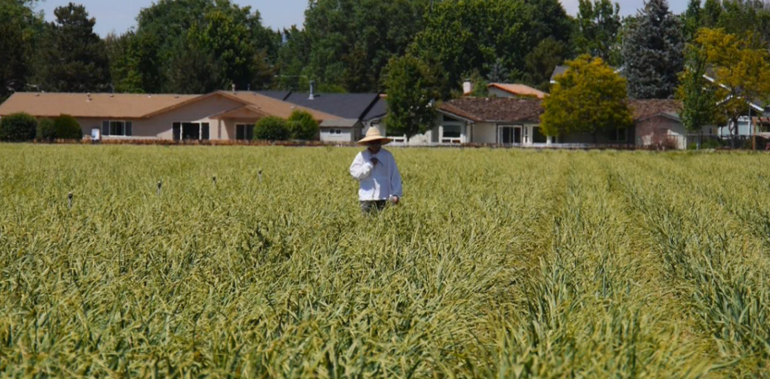
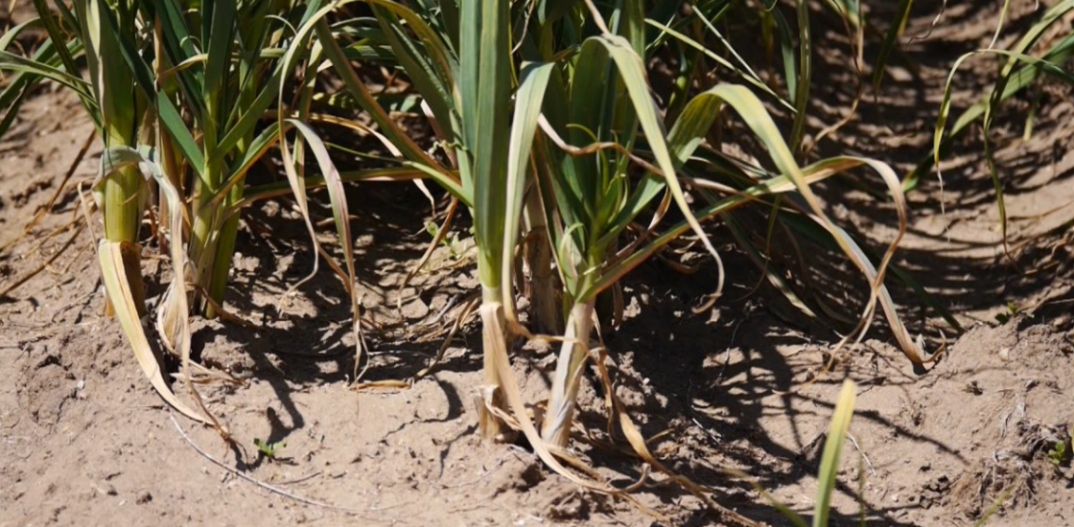
Garlic is planted in rows, 2 to 4 inches apart and 2 inches deep. Rows are spaced 10 to 14 inches apart. As the seed grows a shoot will poke through the soil. During the growing season the shoots can grow to stand a few feet high.
Photo source: Nevada Department of Agriculture

Scenario:
Jane lives in the Nevada suburbs. Next to her house is a ½ acre piece of land owned by her elderly neighbor. He used to have a large garden, but the land hasn’t been used in over a decade. Jane has talked with the neighbor about renting the land for a small fee and growing garlic for seed. She plans to sell her garlic seed at local Farmer’s Markets to those who want to grow garlic at home. Jane is trying to determine the best method to irrigate her ½ acre of garlic seed and is looking for creative engineering designs.

Instructions:
You are a team of agricultural engineers given the challenge of developing an irrigation system that will distribute water to the small garlic field. How you accomplish the task is up to your team!

Note: Worksheet adapted from Irrigation Ideas Developed by IEEE as part of Try Engineering. www.tryengineering.org

Team Member Names___________________________________ Date _________

Planning Phase
As a team discuss design ideas. Consider 1) where do you want the water applied, 2) the layout of the field (distance between rows and plants). Come up with a plan and draw your design in the box below. Be sure to indicate the materials you plan to use.
Design Sketch

Materials Required:

Construction Phase
Build your irrigation system. During construction you may decide you need additional items or that your design needs to change. This is ok -- just make a new sketch and revise your materials list. You may want to trade items with other teams or request additional materials from your teacher.

Testing Phase
Each team will test their irrigation system to see how it functions.

Evaluation Phase
As a team, evaluate your results by answering the questions below.

- Did you succeed in creating an irrigation system? What worked well?

- If your system failed, what do you think went wrong?

- Did you decide to revise your original design while in the construction phase? Why? How?

- Do you think agricultural engineers have to adapt their original plans during the construction of systems or products? Why?

- If you had to do it all over again, how would your planned design change? Why?

